Michael Mendez Portfolio
Letter of introduction:
Dear too whom it may concern:
From an early age, I have been very creative seeking, and learning more to add onto my knowledge. My name is Michael Mendez Jr, and i am writing to tell you a little about myself. After high school, I am planning to apply to Washington Science & Technology University’s Coding & Game and App Design. I have the training, on going learning , and improving my skills on growing my art career for my games and more. I would like to thank you for reading and reviewing my resume.
Sincerely, Michael Mz

Contact information
- Name: Michael Mendez
- Phone #: 681-446-2631
- Email: mikeyjr3152@gmail.com
- secondary Email: gaming_with_michael@outlook.com
Skills and experiences
- basic coding in unity, web design, and Roblox studios
- Studied at James Rumsey Technical Institute.
- Mill Work/Work shop (intermediate)
- Video Management/ Video Editor
- Education: Still in High School
Community portfolio
- Unity play: GWMichael
- GitHub: mmendez2027
Projects
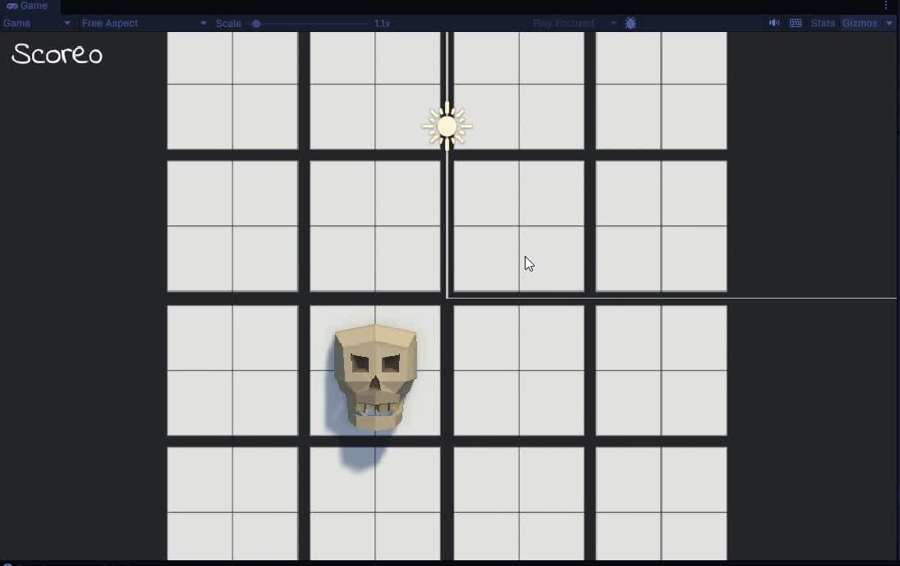  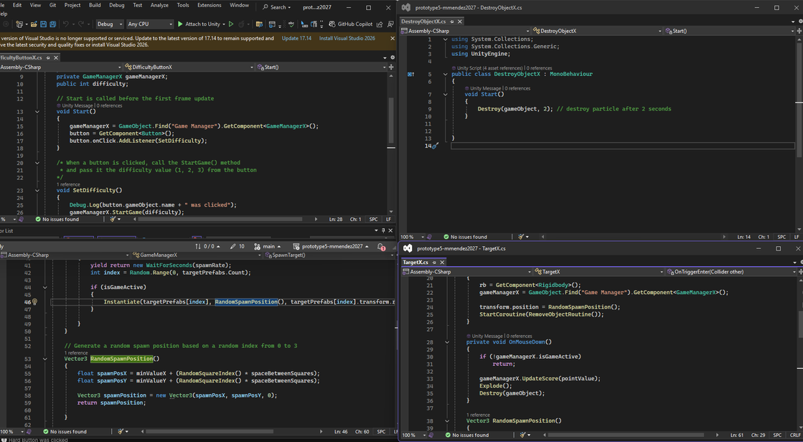 | Whack-A-Food!  Your goal on this game is to click a difficulty and starting clicking the foods, and to make sure not to click on the skulls the more you miss the food it would lead to a game over screen for you to then restart.  https://play.unity.com/api/v1/games/game/cfc4994a-8343-44f3-a671-35215cf912d3/build/latest/frame🍕👆

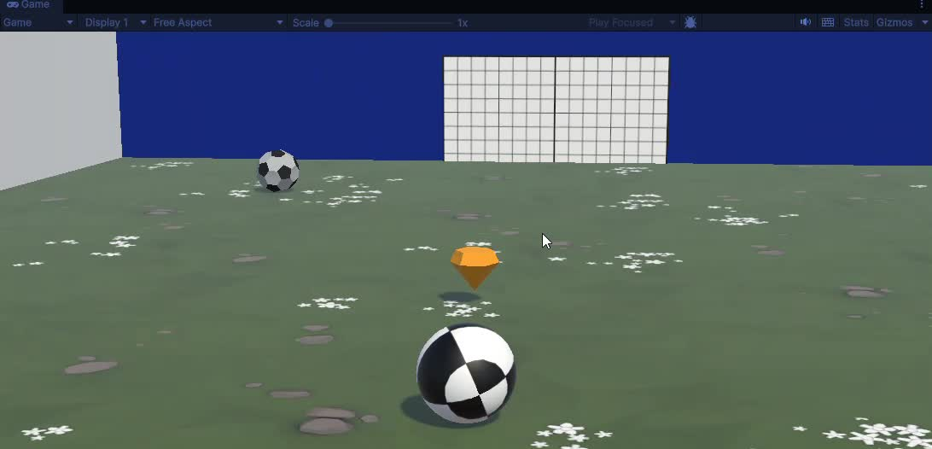 | Soccer Defender  Your goal is to Defend your goal from the soccer balls and put them in their goal. You have a power up that spawns to help you knock the enemy soccer balls back to their goal.
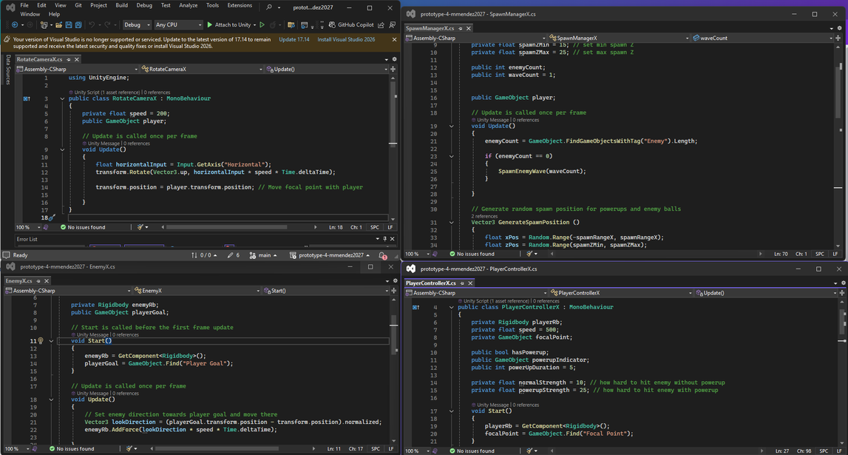
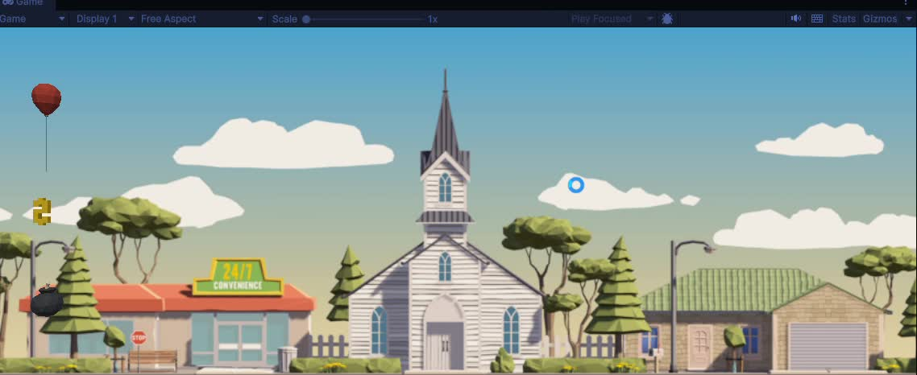 | Balloon City Run  Your goal is to travel the city collect money and dodge bombs (A tester game/Challenge project)
